Dear Burrow Global,

In 2021, my beloved grandmother “Mimi” passed away unexpectedly. She is survived by my grandfather, Noel Taylor. After her death, my grandfather was at a loss of what to do with his time. He joined widowed elders’ groups on Facebook, went to the VA, and helped with handiwork around the house – but nothing seemed to fulfill him. Able-bodied and quick-witted, my grandfather, or “Pepere”, decided to re-enter the workforce. But at 76 years old, his options were incredibly limited. It seemed that, despite his decades of experience in a variety of positions, Pepere couldn’t find a job.

Mimi, me, and Pepere 2003

I was hurt and confused for him. I opened my computer, in search of some sort of explanation. After doing some research, I found that he was not the only one who faced age discrimination. In fact, the practice of ageism in the workplace has become increasingly troublesome in the United States, despite several laws and statues prohibiting it.

Brian Reid, a formal Google employee asserted that he was told; **“his ideas were too old too matter”** and was subsequently laid off at the age of 54. Reid, who is now in his 70’s and has continued to work in the tech industry, says he thinks age discrimination remains a significant problem, as aggressive companies value the new and fresh at the expense of the deep knowledge and experience older workers bring (AARP). Kathryn Moon, a former English professor at Ohio State University made this statement about the University’s management: **"They made explicit references to our age and the desire to get rid of us”** (AARP). Moon and her colleague Julianne Taaffe felt such strong pressure from their boss that they decided to resign. Across the nation, men and women over the age of 45 are struggling to find and keep positions as a younger, less experienced generation rolls in and threatens to take the reins. An article from senior living states that; **“Approximately 453,000 U.S. workers filed age discrimination claims with the Equal Employment Opportunity Commission between 1997 and 2020.”** (Senior Living). In 2020 they reported that 20% of all discrimination claims were age 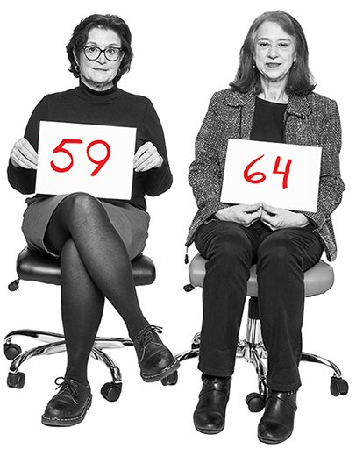focused.

Juliane Taaffe (left) Kathryn Moon (right) taken by Stephen Voss

Among the overwhelming evidence of age discrimination in the workplace I found in my research, a specific incident pulled on my heart. In 2020, a senior level employee for Burrow Global Services LLC, a construction and engineering company, was a victim of age discrimination. The senior employee, a male over the age of 60, had been subjected to repeated verbal questioning on his retirement by his much younger supervisor before being fired. Burrow Global proceeded to offer his position to a junior level employee.

The Equal Employment Opportunity Commission or EEOC, brought up a lawsuit against Burrow Global on the grounds of a violation of the Age Discrimination in Employment Act (ADEA). The resolution of the case is as follows: **“Burrow Global will pay the employee $50,960 in back pay and liquidated damages and will also conduct training regarding the ADEA, update its ADEA policies, post a notice prohibiting discrimination, and provide regular reports to the EEOC”** (EEOC.gov).

Burrow Global, it’s time to set a precedent of change, inclusion, and fairness. While I applaud your efforts to remedy the situation and educate your employees on anti-age discrimination policies; further, concrete actions need to be made to prevent continued discrimination. You must not rely on flashy, multi-million-dollar settlements made by tech giants like Verizon and Google to incite change. You must take responsibility. You must do your part.

I recommend that you require all new employees to undergo anti-age discrimination training and re-train once a year. Furthermore, it would be wise to create new positions for junior employees, perhaps in areas of technology and media (roles they might be more comfortable with than their senior counterparts.) This would ensure that senior employees can remain in positions that they are good at; positions that are vital to the steadfastness of any company. While a financial loss seems imminent with the onset of new positions, I urge you and other companies to consider the benefits of keeping elders inside your workplaces.

Senior workers are more likely to be loyal to a company than their junior counterparts. **According to a 2019 BLS survey, baby boomers had about 12 jobs from ages 18 to 52. Interestingly, nearly half of these positions were held before age 25.** This indicates that, as workers age, they’re more likely to remain with the same company (Indeed).

Senior workers naturally have more experience – be-it “life experience” or career involvement, it’s plain that many elder workers have decades of connections and tools that can strengthen any workplace. Keeping senior-level workers on can also be a great way for juniors to be mentored and refine their skills.



Senior Associate and Junior Associate Working Together

Lastly, senior-level employees add diversity to the workplace. Their unique and valuable experiences allow them to offer insight on issues that younger employees might not think of. Research from the Organization for Economic Cooperation and Development revealed that; **“increasing the share of older workers in a firm by 10 percent boosts productivity by 1.1 percent and reduces turnover by 4 percent”** (Senior Living). Just as having diverse race, gender, and sexual orientation is helpful to problem solving and creativity, including workers of different ages is integral to the well-roundedness of any company; even encouraging productivity.

I propose that you lobby for laws to be passed that ensure a certain percentage of employees over the age of 45 can remain in their positions (or those of equal pay) when lay-offs or rearrangements are being made within a company. These are acts of contrition that would solidify your commitment to enacting lasting change.

The widespread practice of age discrimination in the United States sets companies in grave danger. Despite the threat of lawsuits, employers should be aware of the consequences of omitting seniors from their companies. Employers: if you value loyalty, experience, and diversity, you should be keen to accept and keep senior-level employees on your payroll. It is simply in your best interest.

So, while I urge you to be compassionate and fair to senior employees, I know that might not be incentive enough. Look at the facts. Give Pepere a shot. The wellbeing of your company might very well depend on it.

****************************************************************

Sources:

<https://www.eeoc.gov/newsroom/burrow-global-pay-50960-settle-eeoc-age-discrimination-lawsuit>

<https://www.aarp.org/work/age-discrimination/court-case-stories/>

<https://www.seniorliving.org/research/age-discrimination-statistics-facts/>

<https://www.indeed.com/hire/c/info/ageism-in-the-workplace>